Do UK equity markets react asymmetrically to BoE monetary tightening vs easing?
Do UK equity markets respond asymmetrically to different types of monetary policy shocks (Target, Path, QE), and how do these effects evolve over time?

E[equity response | policy shock]

Literature Review

Methodology
Main section:
- Equity markets (FTSE 250 ideally)
- LPs with:
  - Target
  - Path
  - QE
- Asymmetry (tightening vs easing)
- Horizons: 0-20 days
3D story:
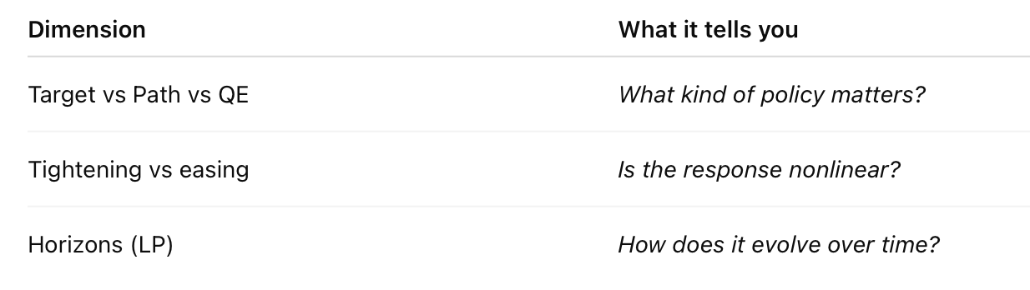
Extension:
- Apply same LP to:
  - FTSE 250 vs 100
  - Sectoral-level
  - 3 dependent variables (for each dependent variable, estimate LPs using all 3 shocks):
    - 2y OIS
    - 5y GBP swap
    - 10y gilt yield

- For main section and extension, run separate LPs for each of the 3 shocks then a joint specification for robustness.

- (ChatGPT written) We estimate dynamic impulse responses using the local projection method of Jordà (2005), which allows flexible estimation of nonlinear and asymmetric effects without imposing the dynamic restrictions of a VAR framework.
- “Monetary policy shocks are identified using high-frequency movements in interest-rate markets. These shocks are then used to study the dynamic and asymmetric response of UK equity markets.”
  - Intraday shocks => daily horizon responses
- LPs let you show:
  - speed of adjustment
  - persistence
  - overshooting
  - delayed responses
  - asymmetry over time

Results
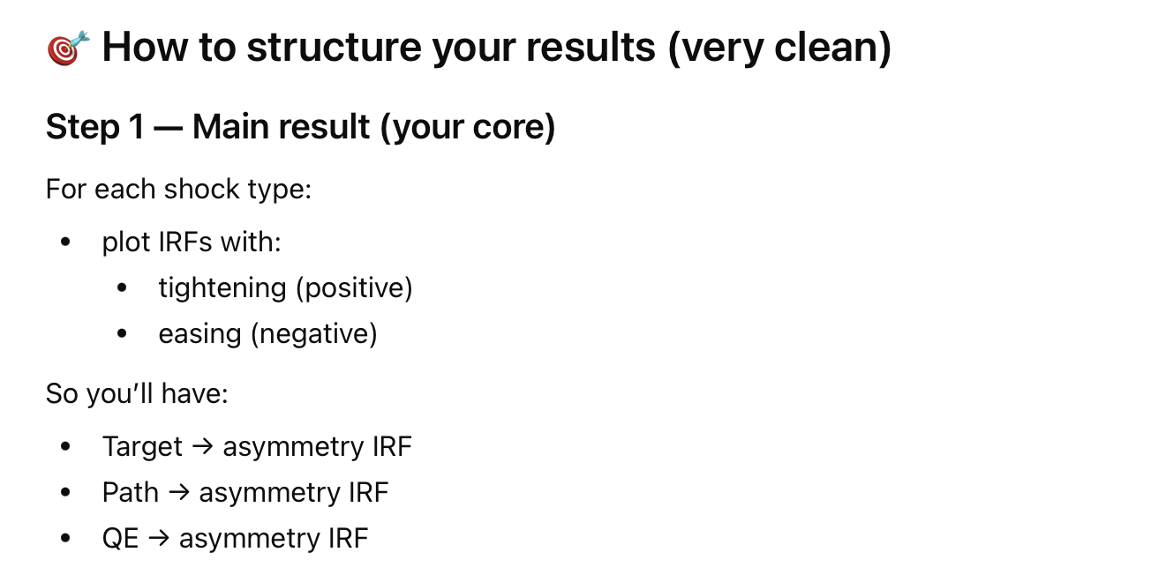
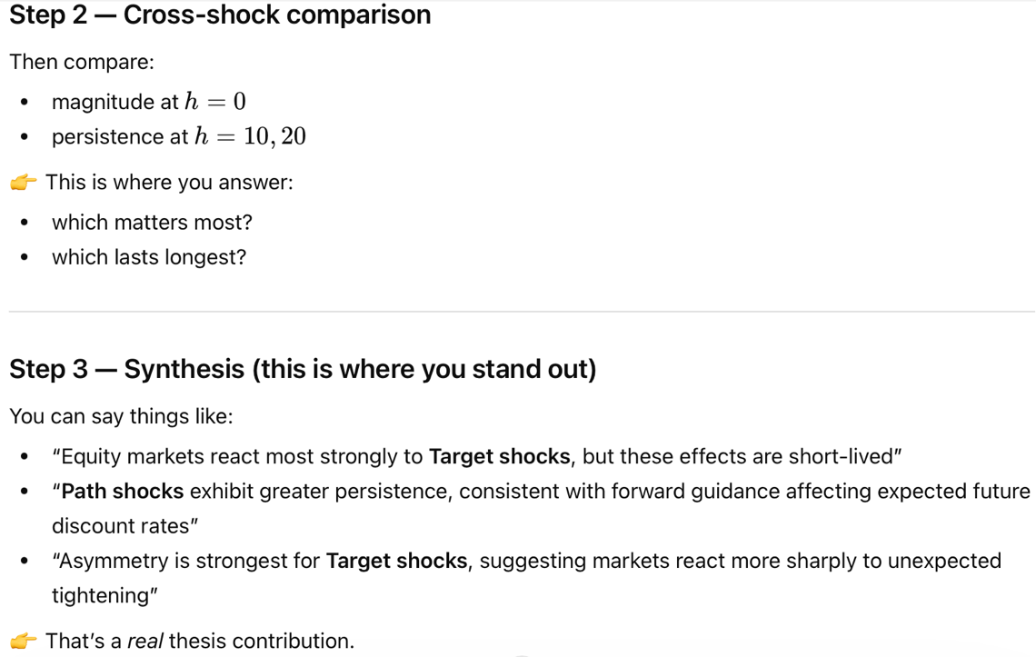

- Inflation expectations

GitHub

- Target: changes in target that weren’t expected
- Path Surprises in forward guidance
- QE surprises

Difference between QE and target

Which month had a big shock and why?

2.1 The Bank of England’s Policy Cycle and Communication Schedule

BoE dual mandate like FED or no? ECB just cares about inflation since Lagarde
In recent years, MPC sets Bank Rate level as sole or primary instrument. Forward guidance introduced explicitly in 2013 but always been there (“monetary policy has now reached a position at which it should be possible to pause in order to assess the direction in which the risks are likely to materialise”, August 1997 committee communication)

conventional monetary policy shocks that operate primarily via changes in the level of the policy rate (Bank Rate) of the Monetary Policy Committee’s (MPC) communication about the future path of policy, and of QE announcements.

Bank Rate shocks tend to move shorter maturity interest rates the most, while communication and QE announcements have larger eﬀects at longer maturities.

MPC announcements (which will capture Inflation Report (IR) / Monetary Policy Report (MPR) announcements in the post-2015 sample) and press conferences (which will capture IR/MPR announcements in the pre-2015 sample

markets extract tightening news about the possible future path of policy when a subset of MPC members votes in favour of a higher Bank Rate.

The main monetary policy publication, at the time called the Inflation Report (IR), followed a quarterly publication schedule and was typically published two weeks after the Bank Rate decision of the same month. The press release that followed the publication of the IR oﬀered a chance for the MPC to share insights into the rationale for the decisions, and to discuss the prevailing judgements that concurred to inform their view of the UK macroeconomic outlook. Starting from August 2015, MPC meetings and policy decisions have been moved to a six-week cycle and, once every quarter, the monetary policy decisions are released together with the publication of the Monetary Policy Report, and of the meeting’s minutes. A press conference then follows on the same day.

A one-oﬀ Bank Rate increase leads to a rise in corporate spreads and sudden repricing in the stock market. Output exhibits a more sluggish response, and contracts over the subsequent year. The inflation response is subdued, but becomes more pronounced when considering a shock to the medium-term policy path, which also elicits a stronger and more prolonged appreciation of the pound. These shocks also lead to a more frontloaded fall in output.

Until 2003 the inflation target was defined in terms of the retail price index excluding mortgage interest rates. Since 1997, the target was set to 2.5 percent annual rate. From 2003 onward, the inflation target has been specified to be 2 percent as measured by the 12-month increase in the consumer price index (Cloyne and Hürtgen, 2016).
Monetary policy announcements were typically scheduled for 12:00 noon local time
BoE Inflation report: February, May, August and November
IR was typically scheduled a week after the Bank Rate announcement, at 10:30 local time, and it was immediately followed by a 1-hour press conference.
The minutes of each MPC decision meeting were published two weeks after each announcement, at 9:30 local time. (Before October 1998, the minutes were published with a six week lag (Reeves and Sawicki, 2005)) – often coincided with data releases that are also likely to substantially influence markets – e.g. Labour Force Survey (unemployment figures), statistics on money and lending activities and, in some instances, even of GDP figures. So release of minutes not included in earlier part of sample

Currently, the monetary policy decision, statement and minutes of each meeting are released jointly, on a Thursday, at 12:00 local time. The main monetary policy publication, later renamed the Monetary Policy Report (MPR), maintained the same quarterly publication cycle. When due, it is published together with the monetary policy decision, and the associated press conference is scheduled on the same day, from 12:30 to 13:30 (originally from 12:45 to 13:45). This quarterly occurrence has come to be known of as the BOE’s “Super Thursday”.
Policy rate Effective lower bound in 2009 => first large-scale asset purchase programme launched (QE) – QE-related announcements are communicated jointly with Bank Rate decisions, and following the same six-week cycle.
The MPC communicates with the public also through speeches.

2.2.1

Following Gürkaynak et al. (2005), we define monetary policy surprises as high-frequency revisions in asset prices around monetary policy events. To ensure that no competing events distort the measurement, monetary policy surprises are calculated over narrow time windows that bracket the announcements, as the difference between
the price that prevails before and after the relevant monetary policy event. (30-minute measurement window, from 10 minutes before to 20 minutes after the announcement)

For the press-conference that follows the release of the IR/MPR, we instead use a longer 75-minute window, from 10 minutes before its beginning to 5 minutes after its end. To avoid misquotes, and following Altavilla et al. (2019), for each event we define the pre-event price as the median quote in the ten minutes before the beginning of each window, and the post-event price as the median quote in the 10 minutes after the end of each window.

In the pre Super Thursday sample (1997-2015), the announcement window includes Bank Rate and other policy announcements (e.g. QE from 2009) and the release of the policy statement. The press conference window instead includes the publication of the IR and the whole duration of the press conference. In the post Super Thursday sample (2015-2023), the press conference window only covers the actual press conference. Policy decisions, the publication of the MPR, as well as the release of the minutes and the statement all enter the announcement window

In the empirical section that follows we also make use of a monetary event window. This is obtained as the union of the announcement and press conference windows. In the pre Super Thursday sample, this translates into an increased number of daily events, due to the announcement and press conference happening on different days over that sample. In the post Super Thursday sample, the monetary event window yields the sum of the price movements across the two windows, which since 2015 happen on the same day.
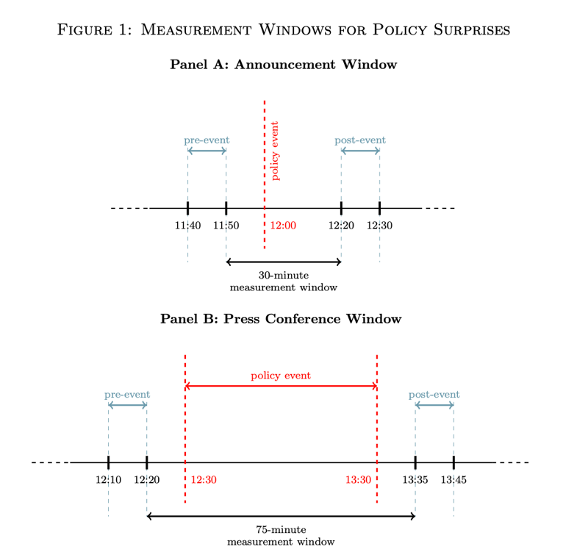
Surprise = post event price – pre event price
where the prices are medians within small windows before and after the event.

High-frequency surprises in asset prices that are directly linked to monetary policy expectations — such as e.g. overnight index swaps (OIS) or interest rate futures — allow us to map the degree to which the monetary policy event triggered a revision in market-based expectations about the path of policy. Surprises in other asset prices, such as the stock market index or the exchange rate, capture the response of these markets to the decisions. Taken in conjunction, the monetary policy surprises from different asset prices allow to gauge how markets interpret the monetary policy decisions. For example, an easing surprise in OIS rates — which can result from the policy rate being lowered by more than expected, or it being hiked by less than expected — can be accompanied by either positive or negative surprises in the stock market. Jarocinski and Karadi (2020) interpret the first case as a conventional monetary policy shock, while attributing the second to information effects, that is, to the central bank implicitly revealing information about deteriorating conditions ahead.

Increasingly, and particularly since the policy rate reached its effective lower bound following the financial crisis of 2008, the MPC has conducted monetary policy through different tools designed to affect specific segments of the yield curve. While conventional Bank Rate policy was aimed predominantly at the short-end, alternative interventions such as forward guidance and QE aim at affecting rates expectations at substantially longer maturities.

Gürkaynak et al. (2005) showed how structural factors could be used to summarise the market reaction to policy decisions at different points of the maturity spectrum. They identified a Target factor that summarised the immediate policy rate decision, and a Path factor that instead captured information about the future path of policy, thus embedding both implicit and explicit forward guidance. Swanson (2021) further developed this intuition to capture the effects of QE announcements.

To estimate the UK-specific factors, we apply the model in Swanson (2021) to monetary surprises in the first four short sterling futures, and in the 2, 5 and 10-year gilt yields. The estimation proceeds in two steps. First, principal components are used to summarise the common variation in the monetary surprises in the seven asset prices.15 Second, additional identifying restrictions are imposed to pin down the structural factors and facilitate their interpretation. Out of the three estimated factors, only the first one (Target) is allowed to load on the first short sterling futures. To distinguish between the second (Path) and third (QE) factors, the variance of the latter is minimised over the pre-2009 sample. The factors are orthogonal to one another by construction.
- They run PCA on Short-term rate expectations (Short sterling futures (3m), Short sterling futures (6m), Short sterling futures (9m), Short sterling futures (12m)) and Longer-term rates (2-year gilt yield, 5-year gilt yield, 10-year gilt yield)
- Then restrictions imposed: Only the Target factor is allowed to affect the shortest maturity future (3-month). Path factor affects medium maturities. QE factor – minimise variance before 2009 because QE did not exist.

BOE’s Target shocks capture short-term monetary policy in a somewhat broader sense relative to equivalent factors extracted for the Fed and the ECB. This is due to sufficiently liquid short-maturity interest rate futures contracts in the UK embedding a three-month maturity. Thus, a Bank Rate shock as defined in this paper has a broader connotation than in the US and EA
Press conferences so more similar to ECB than FED

The largest readings of the Target factor are associated with the policy easing decisions taken in response to the financial crisis of 2008, with the 150bps Bank Rate cut of November 2008 as the single largest observation in our sample. Large Target surprises tend to happen during meetings that are not associated with an IR/MPR publication. It is also worth noting that there is generally little variation in the Target factor during the press conferences. The largest observation of the Path and QE factors are instead more recent, and registered during the Covid pandemic and subsequent recovery. The largest Path surprise is February 2022, when it became clear that a hiking cycle had begun, and that the indicative Bank Rate threshold that the MPC had set to start reversing QE was nearer than previously thought. Very interestingly, the largest QE surprise does not correspond to the first QE round of 2009, which had been amply communicated in advance, and is instead associated with the additional £200 billion of asset purchases that were announced in March of 2020 after the UK economy had entered its first lockdown.

UK short-term rate surprises tend to be heavier-tailed than in the US and the EA. This is especially true in the period around the financial crisis of 2008, where the UK registered the sharpest moves in the front-end, potentially reflecting somewhat higher uncertainty around policy relative to the other regions. Conversely, large Path and QE surprises seem to be more prevalent for the US and EA respectively, which may reflect different combinations of policy tools used by the three central banks.

Results:
where change(y_{t}) denotes the daily or intradaily change in the relevant asset price, and Target_{t}, Path_{t} and QE_{t} are the monetary policy factors all normalised such that an increase in the factor corresponds to a tightening of the monetary policy stance.

Using a narrow measurement window guarantees that, absent other contemporaneous events, the monetary policy surprises (and related factors) measure the extent to which the decision was interpreted as a surprise, or news, by market participants. However, whether that price revision can be used to proxy for a monetary policy shock is a different matter. As noted earlier, confounding factors such as information effects may still be present.
(Information effects occur when central bank announcements reveal new information about the economy, causing stocks and yields to move in the same direction, which contaminates identification of true monetary policy shocks)

Monetary policy news days are those where the high-frequency correlation between each of the extracted factors and the FTSE 250 index is negative
Positive correlation => information effect

Compare BoE with FED and ECB – BoE more transparent like ECB => Info effects more present than in FED

Consistently, we find that like for the ECB, a little over half of the BOE surprises are classified as monetary policy events, with the share raising to 60% for Bank Rate announcements.

2009 QE
Started: March 2009
Initial size: £75 billion
Policy rate at the time: 0.5% (effective lower bound)
Purpose: stimulate the economy when conventional policy (rate cuts) could no longer do much.
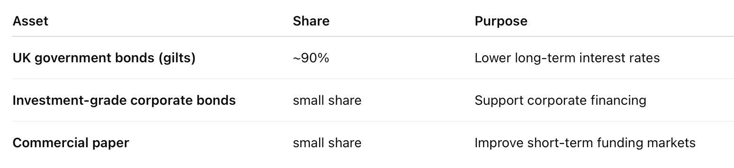

August 2016 (Post Brexit)
“most members of the Committee expect monetary policy to be loosened in August. The precise size and nature of any stimulatory measures will be determined during the August forecast and Inflation Report round” – This included a new Term Funding Scheme to reinforce the pass-through of the Bank Rate cut; the purchase of up to £10 billion of UK corporate bonds; and an expansion of the asset purchase scheme for UK government bonds of £60 billion, taking the total stock of these asset purchases to £435 billion.
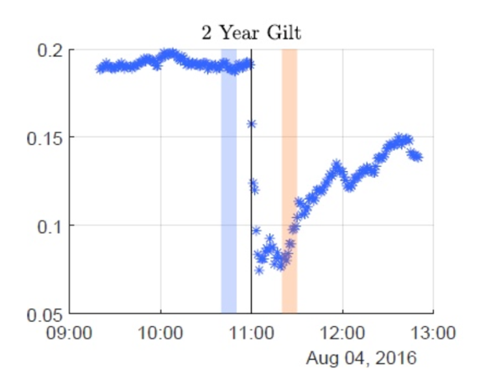

Covid
Maintained rates but changed forward guidance: “Further ahead [...] some modest tightening of policy, at a gradual pace and to a limited extent, may be needed to maintain inflation sustainably at the target.” => “at a gradual pace and to a limited extent” was removed

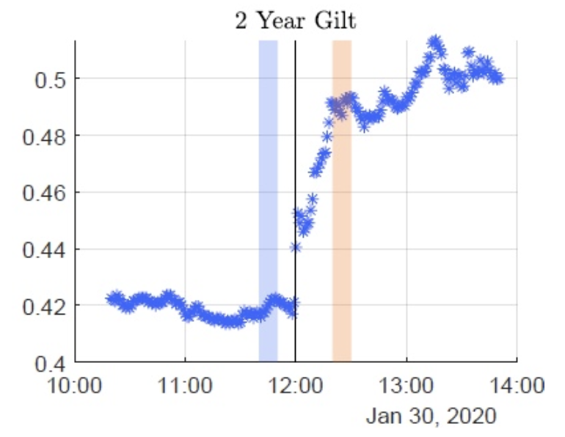

Intuition: Why Might Asymmetry Exist?
Theoretically:
- Tightening increases discount rates → strong equity drop
- Easing may signal bad macro outlook → weaker positive response
- Risk premia channel may be nonlinear
- ZLB may make easing less effective
So you have strong economic motivation.

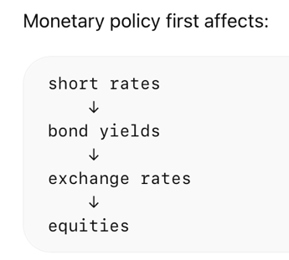

Shocks:
- Target = short rate surprise (strongest in terms of in terms of transmission in equity)
- Path = forward guidance shock
- QE = long-term asset purchase shock

PCA of (BoE paper deals with instant reactions – price after minus price before):
- 3M LIBOR (London Interbank Offered Rate) quarterly contracts: If LIBOR (3-month GBP) = 5% => banks could borrow 3-month money from other banks at about 5%.
- 3M SONIA (Sterling Overnight Index Average) quarterly contracts: 3 Month SONIA futures contract [If SONIA today = 5% => banks are actually lending overnight funds at around 4.25% - payoff of 3M future depends on average price over the 3 month period in question] – moves very closely with BoE policy rate
  - LIBOR and SONIA considered most liquid measure of interest rate expectations in UK
- OIS (Overnight Index Swap) Rate: betting on average SONIA over next period (specified). Because expected SONIA indicates expected Bank Rate, we then have that OIS Rate indicates expected future policy rate.
  - More directly linked to Bank Rates expectations but only available from 2008
- Gilt yields => medium to long term rate expectations

Dependents:
- FTSE100 and/or FTSE250 (start simple) – daily
- Sectoral – daily
VAR
or LP – less biased (especially at long horizons) – but less precise (bigger confidence intervals)
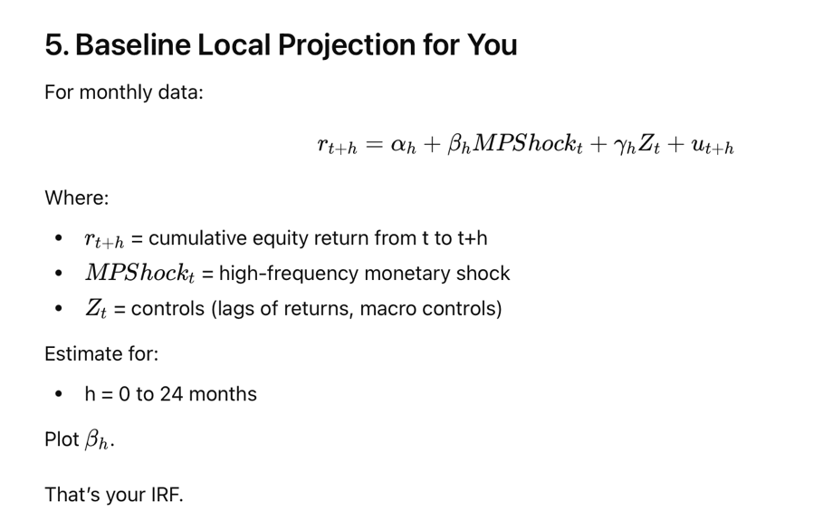
Because your shocks are high-frequency surprises:
- They are already unexpected components
- They are close to structural shocks
So:
β_{h} = causal effect of an unexpected monetary tightening at time t on equity returns at horizon h

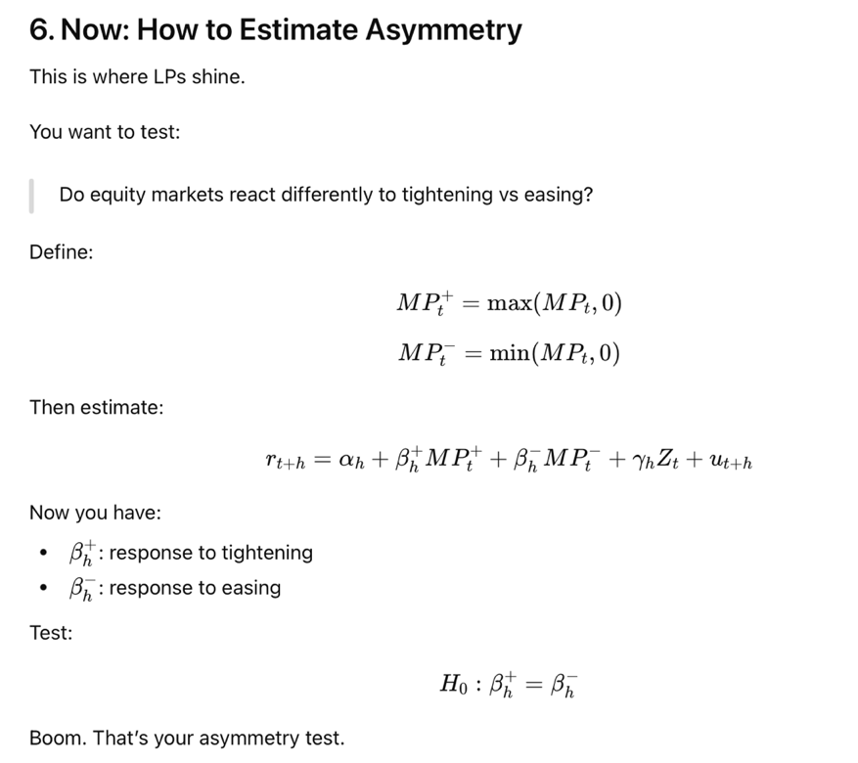

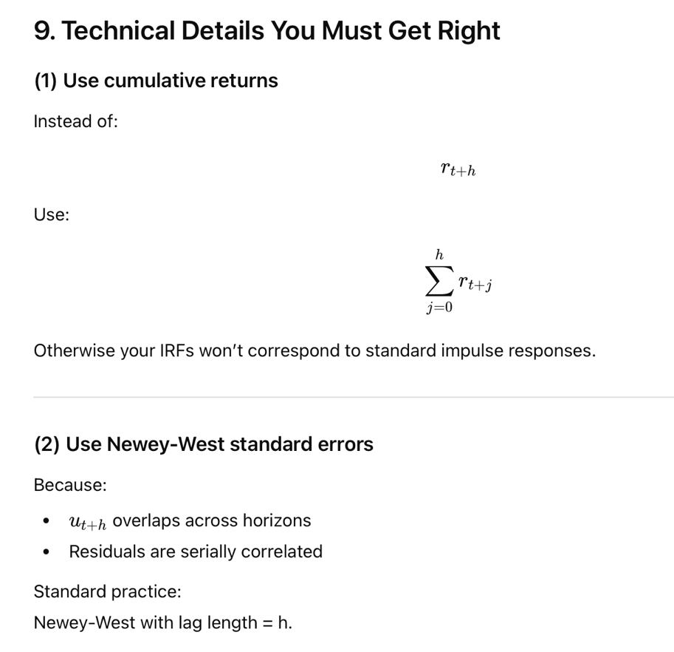
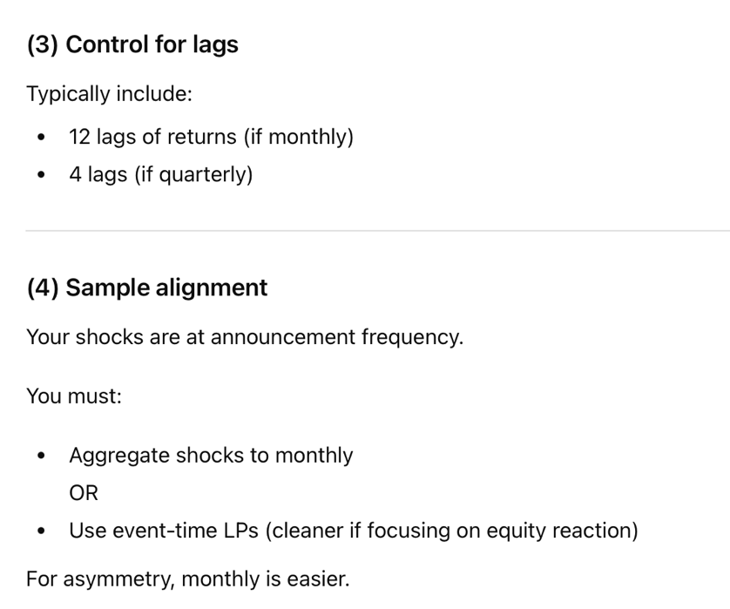

Output:
Two IRFs:
- Tightening shock IRF
- Easing shock IRF
With confidence bands.

The asymmetry will show as:
- Larger negative effect for tightening?
- Smaller positive effect for easing?
- Different persistence?
That’s your contribution.

BoE working paper – VAR-based IRFs => I’m using LPs

Extensions:
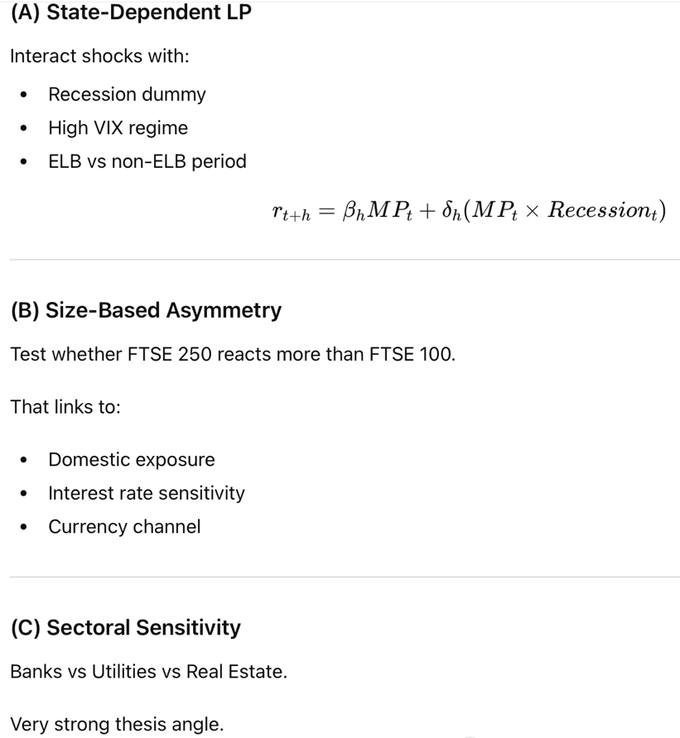

Citing UKMPD: Braun, Miranda-Agrippino and Saha, "Measuring Monetary Policy in the UK: the UK Monetary Policy Event-Study Database", Journal of Monetary Economics (2024)

Jarocinski, Marek and Peter Karadi (2020) “Deconstructing Monetary Policy Surprises—The Role of Information Shocks,” American Economic Journal: Macroeconomics, Vol. 12, No. 2, pp. 1–43, April.

effect of the Bank of England’s communication using the variance of asset prices around announcements
Reeves, Rachel and Michael Sawicki (2005) “Do Financial Markets React to Bank of England Communication?,” Discussion Papers 15, Bank of England, External MPC Unit.

detailed analysis of the information content of MPC speeches, and have shown that financial markets respond strongly to this type of communication
Mumtaz, Haroon, Jumana Saleheen, and Roxane Spitznagel (2023) “Keep it Simple: Central Bank Communication and Asset Prices,” Working Papers 960, Queen Mary University of London, School of Economics and Finance.

apply a term structure model to monetary policy surprises in gilt yields to study the monetary policy transmission in the UK during QE.
Kaminska, Iryna and Haroon Mumtaz (2022) “Monetary policy transmission during QE times: role of expectations and term premia channel,” Bank of England working papers 978, Bank of England.

estimate the causal effects of monetary policy, building on the seminal work of
Kuttner, Kenneth N (2001) “Monetary policy surprises and interest rates: Evidence from the Fed funds futures market,” Journal of Monetary Economics, Vol. 47, No. 3, pp. 523–544.

Joyce, Michael, Jonathan Relleen, and Steffen Sorensen (2008) “Measuring monetary policy expectations from financial market instruments,” Bank of England working papers 356, Bank of England.

Cloyne, James and Patrick Hürtgen (2016) “The Macroeconomic Effects of Monetary Policy: A New Measure for the United Kingdom,” American Economic Journal: Macroeconomics, Vol. 8, No. 4, pp. 75–102, October

Gürkaynak, Refet S, Brian Sack, and Eric Swanson (2005) “Do Actions Speak Louder Than Words? The Response of Asset Prices to Monetary Policy Actions and Statements,” International Journal of Central Banking, Vol. 1, No. 1, May.

Altavilla, Carlo, Luca Brugnolini, Refet S Gürkaynak, Roberto Motto, and Giuseppe Ragusa (2019) “Measuring euro area monetary policy,” Journal of Monetary Economics, Vol. 108, pp. 162–179.

Swanson, Eric T (2021) “Measuring the effects of federal reserve forward guidance and asset purchases on financial markets,” Journal of Monetary Economics, Vol. 118, pp. 32–53.

Miranda-Agrippino, Silvia (2016) “Unsurprising shocks: information, premia, and the monetary transmission,” Bank of England working papers 626, Bank of England.

Gerko, Elena and Hélène Rey (2017) “Monetary Policy in the Capitals of Capital,” Journal of the European Economic Association, Vol. 15, No. 4, pp. 721–745, 08.

Cesa-Bianchi, Ambrogio, Gregory Thwaites, and Alejandro Vicondoa (2020) “Monetary policy transmission in the United Kingdom: A high frequency identification approach,” European Economic Review, Vol. 123, No. C.

whether the effect of policy news depends on the degree of dissent amongst Committee members
Gerlach-Kristen, Petra (2004) “Is the MPC’s Voting Record Informative about Future UK Monetary Policy?,” Scandinavian Journal of Economics, Vol. 106, No. 2, pp. 299–313, June.

Riboni, Alessandro and Francisco Ruge-Murcia (2014) “Dissent in monetary policy decisions,” Journal of Monetary Economics, Vol. 66, pp. 137–154.

Miranda-Agrippino, Silvia and Tsvetelina Nenova (2022) “A tale of two global monetary policies,” Journal of International Economics, Vol. 136, p. 103606.

https://www.bankofengland.co.uk/inflation-report/1997/august-1997

https://www.lseg.com/en/data-analytics/market-data/data-feeds/tick-history

https://www.bankofengland.co.uk/monetary-policy-summary-and-minutes/2016/mpc-august-2016
https://www.bankofengland.co.uk/monetary-policy-summary-and-minutes/2019/november-2019
https://www.bankofengland.co.uk/monetary-policy-summary-and-minutes/2020/january-2020

Next steps:
- Run baseline LP (linear)
- Then split into tightening vs easing

